**HEALTH SAVING ACCOUNTS (HSAs)**

**Introduction:**

Health Savings Accounts (HSAs) are specialized savings accounts in the U.S. designed to help individuals save for medical expenses. They are available to those enrolled in high-deductible health plans (HDHPs) and offer significant tax advantages, making them a powerful tool for managing healthcare costs. Contributions to HSAs are tax-deductible, and withdrawals for qualified medical expenses are tax-free, providing a triple tax benefit: tax-deductible contributions, tax-free growth, and tax-free withdrawals.

For 2024, the contribution limits are $3,750 for individuals and $7,500 for families, with an additional $1,000 catch-up contribution allowed for those aged 55 and older. Unlike Flexible Spending Accounts (FSAs), HSA funds roll over year to year and accumulate without expiration, and the account remains with the individual regardless of employment status or changes in health coverage.

HSAs can also be invested in mutual funds, stocks, and other vehicles to grow the savings. Employers may contribute to employees' HSAs, adding to the account’s benefits. As healthcare costs continue to rise, HSAs provide a strategic way to budget for out-of-pocket expenses while also serving as a supplemental retirement savings account due to their long-term growth potential and tax advantages. Here are some key points about HSAs:

**1. Purpose:** HSAs are designed to help individuals save for medical expenses not covered by their HDHP, such as deductibles, copayments, and other qualified medical expenses.

**2. Tax Advantages:** Contributions to HSAs are tax-deductible, and withdrawals used for qualified medical expenses are tax-free. This provides a triple tax advantage: tax-deductible contributions, tax-free growth of funds, and tax-free withdrawals for medical expenses.

**3. Contribution Limits:** There are annual contribution limits set by the IRS. For 2024, the contribution limit is $3,750 for individuals and $7,500 for families (these limits may change annually).

**4. Ownership and Portability:** HSAs are owned by the individual, not the employer, which means the account stays with you even if you change jobs or health plans. The funds in an HSA roll over year to year and accumulate, similar to a retirement account, without expiration.

**5. Investment Options:** Some HSAs offer investment options beyond a standard savings account, allowing individuals to potentially grow their savings over time.

**6. Eligibility:** To open an HSA, you must be covered by an HDHP, not be enrolled in Medicare, and not be claimed as a dependent on someone else's tax return.

**Eligibility Criteria**

**1. High-Deductible Health Plan (HDHP):**

**- Definition:** For 2024, an HDHP is defined as a health plan with a minimum deductible of $1,600 for individual coverage or $3,200 for family coverage.

**- Out-of-Pocket Maximums:** The maximum out-of-pocket limits for HDHPs are $8,050 for individuals and $16,100 for families.

**2. Other Requirements:**

- You cannot have any other health coverage that is not an HDHP.

- You cannot be enrolled in Medicare.

- You cannot be claimed as a dependent on someone else's tax return.

**Contributions**

**1. Contribution Limits:**

- For 2024, the maximum contribution limit is $3,750 for individuals and $7,500 for families.

- If you're 55 or older, you can contribute an additional $1,000 as a catch-up contribution.

**2. Tax Treatment:**

**- Pre-Tax Contributions:** Contributions can be made pre-tax through payroll deductions if your employer offers this option.

**- Post-Tax Contributions:** If you contribute post-tax, you can claim a tax deduction when you file your taxes.

**Using HSA Funds:**

**1. Qualified Medical Expenses:** These include, but are not limited to, doctor visits, prescription medications, dental and vision care, and medical equipment.

**2. Non-Qualified Expenses:** If HSA funds are used for non-qualified expenses before age 65, they are subject to income tax and a 20% penalty. After age 65, funds can be used for non-medical expenses without penalty, but they are subject to income tax.

**Benefits:**

**1. Triple Tax Advantage:**

**- Tax-Deductible Contributions:** Contributions reduce your taxable income.

**- Tax-Free Growth:** Interest and investment earnings grow tax-free.

**- Tax-Free Withdrawals:** Withdrawals for qualified medical expenses are tax-free.

**2. Long-Term Savings:** Funds roll over year to year and accumulate, unlike Flexible Spending Accounts (FSAs) which typically have a use-it-or-lose-it rule.

**3. Portability:** The account remains with you regardless of employment status or changes in health coverage.

**Account Management and Investments:**

**1. Account Providers:** Banks, credit unions, insurance companies, and specialized HSA administrators offer these accounts.

**2. Investment Options:** Depending on the provider, you might have options to invest in mutual funds, stocks, or other investment vehicles to grow your HSA balance.

**Employer Contributions:**

**1. Matching Contributions:** Some employers contribute to their employees' HSAs, which is considered a benefit and is not taxable to the employee.

**2. Incentives:** Employers might also provide incentives for participating in wellness programs or completing health assessments.

**Strategic Use:**

**1. Retirement Planning:** HSAs can serve as a supplemental retirement account because of their tax advantages and ability to pay for medical expenses in retirement.

**2. Health Care Budgeting:** Helps individuals budget for high-deductible health plans by providing a dedicated account for out-of-pocket expenses.

**Regulatory Oversight:**

**1. IRS Rules:** The Internal Revenue Service (IRS) sets annual contribution limits, eligibility criteria, and rules regarding qualified medical expenses.

**2. Compliance:** It's essential to maintain records and receipts for HSA expenditures to ensure compliance and avoid potential penalties during audits.

**Future Changes:**

**- Legislative Adjustments:** Contribution limits and rules regarding HSAs may change annually based on inflation adjustments and legislative updates.

**Here is the data on HSA contribution limits for the past six years (2019-2024)**

|  |  |  |  |
| --- | --- | --- | --- |
| Year | Individual Limit ($) | Family Limit ($) | Catch-up Contribution ($) |
| 2019 | 3500 | 7000 | 1000 |
| 2020 | 3550 | 7100 | 1000 |
| 2021 | 3600 | 7200 | 1000 |
| 2022 | 3650 | 7300 | 1000 |
| 2023 | 3750 | 7500 | 1000 |
| 2024 | 3750 | 7500 | 1000 |

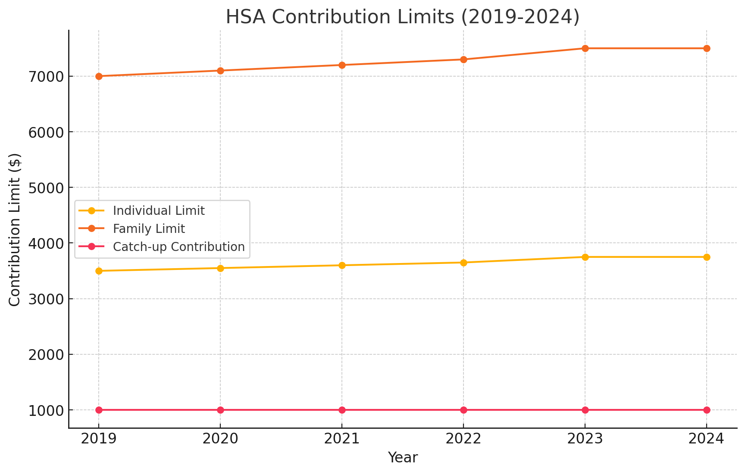

The graph depicting HSA contribution limits from 2019 to 2024 illustrates notable trends in both individual and family contributions. Over this five-year period, individual contribution limits have increased steadily, starting from $3,500 in 2019 and reaching $3,750 by 2023. This gradual rise reflects adjustments for inflation and the escalating costs of healthcare, ensuring that individuals can save more to cover their medical expenses. Notably, from 2023 to 2024, the individual limit remains constant at $3,750, indicating a period of stabilization.

Similarly, the family contribution limits have shown a consistent upward trend, beginning at $7,000 in 2019 and increasing to $7,500 by 2023. This increase supports families in managing their healthcare expenses more effectively. Like the individual limits, the family contribution limit stabilizes at $7,500 from 2023 to 2024, reflecting a potential alignment with current economic conditions and healthcare cost trends.

The catch-up contribution limit for individuals aged 55 and older has remained consistent at $1,000 throughout the entire period from 2019 to 2024. This consistency provides a reliable additional savings option for older individuals, allowing them to bolster their healthcare savings as they approach retirement.

Overall, the graph underscores a general trend of gradual increases in both individual and family HSA contribution limits, ensuring that account holders can continue to benefit from these tax-advantaged savings vehicles amidst rising healthcare costs. The recent stabilization of these limits suggests a pause in adjustments, possibly due to current economic conditions. The unchanging catch-up contribution limit offers steady support for older savers. Staying informed about these annual changes is crucial for maximizing HSA benefits and effectively planning for healthcare expenses.